

COURSE INFORMATIO 
 | School/Faculty: |  |  |  |  | Language Academy, FSSH
 | Program name: |  |  |  |  | All undergraduate programmes (Level 6)
 | Course code: |  |  |  |  | UHLM1012 |  |  |  |  |  |  | Academic  Session/  Semester: |  |  | 2024/2025-2
 | Course name: |  |  |  |  | Bahasa Malaysia Komunikasi 2 |  |  |  |  |  |  | Pre/co requisite (course name and code, if applicable): |  |  | Nil
 | Credit hours:
 | Course synopsis |  |  |  |  | Kursus ini membolehkan pelajar antarabangsa berkomunikasi dalam bahasa Melayu asas yang meliputi situasi kehidupan harian. Pelajar dapat membaca dan memahami ayat Bahasa Melayu mudah selain menulis karangan pendek menggunakan ayat mudah. Pengajaran dan pembelajaran akan dilaksanakan dalam bentuk kuliah, tugasan dan pengalaman pembelajaran pelajar di dalam dan di luar kelas.
 | Course coordinator (if applicable) |  |  |  |  | Dr. Zaliza binti Mohamad Nasir
 | Course lecturer(s) |  |  |  |  | Name |  |  |  |  |  |  |  |  | Office | Contact no. | E-mail
 |  |  |  |  |  | Dr. Zaliza binti Mohamad Nasir |  |  |  |  |  |  |  |  | D05- 318 | 013-7403995 | m-zaliza@utm.my
 |  |  |  |  |  | Cik Nurul Najihah Ahmad |  |  |  |  |  |  |  |  |  | 012-6784210 | anurulnajiha@gmail.com
 |  |  |  |  |  | Pn. Suhaila Mahadi |  |  |  |  |  |  |  |  |  | 019-8833087 | suhailamahadi@gmail.com
 | Mapping of the Course Learning Outcomes (CLO) to the Programme Learning Outcomes (PLO), Teaching & Learning (T&L) methods and Assessment methods:
 | No. |  | CLO* |  |  |  |  |  |  |  | PLO  (MQF  Cluster Code) |  | Taxonomies and  generic skills |  |  | T&L methods | Assessment methods
 | CLO1 |  | Membaca dan menjelaskan maksud ayat serta petikan mudah. |  |  |  |  |  |  |  | PLO5 (C3C) |  | SOCIAL INTELLIGENCE P3, C1 |  |  | - Kuliah  - Pembelajaran Aktif  - Aktiviti Latih Tubi (Membaca Teks) | Latihan (10%)  Quiz (20%)
 | CLO2 |  | Bertutur dalam situasi tertentu dengan menggunakan ayat mudah. |  |  |  |  |  |  |  | PLO5 (C3C) |  | SOCIAL INTELLIGENCE P3, C3 |  |  | - Kuliah  - Pembelajaran Aktif  - Aktiviti Ucapan Spontan | Tugasan Individu (20%)
N

 | CLO3 |  | Menyusun idea dalam penulisan/pengucapan karangan pendek. |  |  |  |  |  |  |  | PLO5 (C3C) |  | SOCIAL INTELLIGENCE P3, CS1 |  |  | - Kuliah  - Pembelajaran Aktif  - Pembentangan |  | Tugasan Kumpulan (30%)  Lisan (20%)
 | Details on Innovative T&L practices:
 | No. | Type |  |  |  |  |  |  |  |  | Implementation
 | 1 | Membaca |  |  |  |  |  |  |  |  | Dijalankan melalui aktiviti di dalam kelas.
 | 2 | Ucapan Spontan |  |  |  |  |  |  |  |  | Dijalankan melalui aktiviti di dalam kelas.
 | 3 | Karangan pendek |  |  |  |  |  |  |  |  | Dijalankan melalui aktiviti di dalam kelas
 | 4 | Pembentangan |  |  |  |  |  |  |  |  | Dijalankan melalui tugasan berkumpulan. Pelajar akan diberi tajuk tugasan yang memerlukan mereka untuk menyediakan video pembentangan
 | Transferable skills (generic skills learning in course of study which can be useful and utilised in other settings) :
 | Student learning time (SLT) / Effective Learning Time (ELT) details:
 | Week/ Meeting |  | Course Content Outline and Subtopics |  |  | CLO* |  | Learning and Teaching Activities |  |  |  |  |  |  |  |  |  |  | TOTAL SLT
 |  |  |  |  |  |  |  | Face-to-Face (F2F) |  |  |  |  |  |  |  | Non F2F Independent Learning |  |  | TOTAL SLT
 |  |  |  |  |  |  |  | Physical |  |  |  | Online (Synchronous) |  |  |  | Online (Asynchronous) |  | Others | TOTAL SLT
 |  |  |  |  |  |  |  | L | T | P | O | L | T | P | O |  |  | Others | TOTAL SLT
 | Kuliah 1 |  | Pengenalan dan taklimat:  Maklumat Kursus  kaedah tugasan  penggunaan buku rujukan |  |  | 1-4 |  | 1 |  |  | 1 |  |  |  |  |  |  | 2 | 4
 | Kuliah 2 |  | Bunyi dan Sebutan  - Bunyi Vokal  - Bunyi Diftong |  |  | 1-4 |  | 1 |  |  | 1 |  |  |  |  |  |  | 2 | 4
 | Kuliah 3 |  | Bunyi dan Sebutan  - Bunyi Konsonan  - Bunyi Gugusan Konsonan |  |  | 1-4 |  | 1 |  |  | 1 |  |  |  |  |  |  | 2 | 4
 | Kuliah 4 |  | Saya, Kawan dan Keluarga  - Memperkenalkan Diri |  |  | 1-4 |  | 1 |  |  | 1 |  |  |  |  | 1 |  | 2 | 5
 | Kuliah 5 |  | Saya, Kawan dan Keluarga  - Ahli Keluarga  - Kawan/Sahabat  Latihan (10%) |  |  | 1-4 |  | 1 |  |  | 1 |  |  |  |  | 2 |  | 2 | 6
 | Kuliah 6 |  | - Sistem Nombor  - Mata Wang Malaysia |  |  | 1-4 |  | 1 |  |  | 1 |  |  |  |  | 2 |  |  | 4
 | Kuliah 7 |  | - Hari dan Bulan  - Tarikh |  |  | 1-4 |  | 1 |  |  | 1 |  |  |  |  | 2 |  | 2 | 6
 | Kuliah 8 |  | - Kata Keterangan Waktu |  |  | 1-4 |  | 1 |  |  | 1 |  |  |  |  | 2 |  |  | 4
 | Kuliah 9 |  | - Kata Tanya.  Kuiz (20%) |  |  | 1-4 |  | 1 |  |  | 1 |  |  |  |  | 2 |  |  | 4
 | Kuliah 10 |  | Persekitaran  - Aktiviti Seharian / Hobi  - Tempat-tempat Penting di Sekitar Kampus |  |  | 1-4 |  | 1 |  |  | 1 |  |  |  |  | 2 |  |  | 4
 | Kuliah 11 |  | Persekitaran  - Tempat tinggali  - Di cafeteria / Restoran |  |  | 1-4 |  | 1 |  |  | 1 |  |  |  |  |  |  |  | 2
 | Kuliah 12 |  | Tugasan Individu (20%) |  |  | 1-4 |  | 1 |  |  | 1 |  |  |  |  |  |  | 3 | 5
 | Kuliah 13 |  | * Pembentangan Tugasan Kumpulan (30%) |  |  | 1-4 |  | 1 |  |  | 1 |  |  |  |  |  |  | 3 | 5
 | Kuliah 14 |  | Ujian Lisan (20%) |  |  | 1-4 |  | 1 |  |  | 1 |  |  |  |  |  |  | 1 | 3
 |  |  |  |  |  |  |  |  |  |  |  |  |  |  |  | SUB-TOTAL SLT : |  |  | 60
 | Continuous Assessment |  |  |  |  |  |  | % |  | Face-to-Face (F2F) |  |  |  |  |  | NF2F  Independent Learning for Assessment |  |  | TOTAL SLT
 |  |  |  |  |  |  |  |  |  | Physical |  |  | Online (Synchronous) |  |  | Online (Asynchronous) |  | Others | TOTAL SLT
 | 1 | Latihan |  |  |  |  |  | 10 |  | 1 |  |  |  |  |  |  |  | 1 | 2
 | 2 | Kuiz |  |  |  |  |  | 20 |  | 1 |  |  |  |  |  |  |  | 1 | 2
 | 3 | Tugasan Individu |  |  |  |  |  | 20 |  | 4 |  |  |  |  |  |  |  | 4 | 8
 | 4 | Tugasan Kumpulan |  |  |  |  |  | 30 |  | 4 |  |  |  |  |  |  |  | 2 | 6
 | 5 | Ujian Lisan |  |  |  |  |  | 20 |  | 1 |  |  |  |  |  |  |  | 1 | 2
 |  |  |  |  |  |  |  |  |  |  |  |  |  |  |  | SUB-TOTAL SLT : |  |  | 20
 | Summative Assessment |  |  |  |  |  |  | % |  | Face-to-Face (F2F) |  |  |  |  |  | NF2F  Independent Learning for Assessment |  |  | TOTAL SLT
 |  |  |  |  |  |  |  |  |  | Physical |  |  | Online (Synchronous) |  |  | Online (Asynchronous) |  | Others | TOTAL SLT
 | 1 |  |  |  |  |  |  |  |  |  |  |  |  |  |  |  |  |  | 0
 |  |  |  |  |  |  |  |  |  |  |  |  |  |  |  | SUB-TOTAL SLT : |  |  | 0
 |  |  |  |  |  |  |  |  |  |  |  |  |  |  |  | SLT for Assessment: |  |  | 20
 |  |  |  |  |  |  |  |  |  |  |  |  |  |  |  | GRAND TOTAL SLT: |  |  | 80
 | A | % SLT for F2F Physical Component |  |  |  |  |  |  |  |  |  |  |  |  |  | 47.30
 | B | % SLT for Online & Independent Learning Component : |  |  |  |  |  |  |  |  |  |  |  |  |  | 52.70
 | C | %SLT for Online Component: |  |  |  |  |  |  |  |  |  |  |  |  |  | 16.25
 | D | % SLT for All Practical Component: |  |  |  |  |  |  |  |  |  |  |  |  |  | 0.00
 | D1 | % SLT for F2F Physical Practical Component: |  |  |  |  |  |  |  |  |  |  |  |  |  | 0.00
 | D2 | % SLT for F2F Online Practical Component: |  |  |  |  |  |  |  |  |  |  |  |  |  | 0.00
Please tick (/) if this course is Industrial Training/ Clinical Placement/
Practicum using 50% of Effective Learning Time (ELT)
 | Identify special requirement or resources to deliver the course (e.g.,software,nursery, computer lab, simulation room etc)
 | Bilik kuliah yang lengkap dengan komputer, Projektor LCD, Internet, Pembesar suara, microphone dan speaker
 | References (include required and further readings, and should be the most current)
Text book (if applicable)
n/a

Main references
Byrnes C.,Tam Lay Suan and Eva Nyimas. (2016). Complete Malay (Bahasa Malaysia). Great Britian : John Murray Learning.

Ibrahim Ismail. (2005). Daily Conversation in Malay. A Concise Guide for Travellers. Kuala Lumpur : Golden Books Centre Sdn Bhd.

Ismail Dahaman. (2000). Pedoman Ejaan dan Sebutan Bahasa Melayu. Kuala Lumpur : Dewan Bahasa Dan Pustaka.

Kamarul Afendey Hamimi. (2015). Bahasa Melayu Komunikasi. Kuala Lumpur : Oxford Fajar

Nor Hashimah Jalaluddin, Mardian Shah Omar & Noor Zilawati Jais. (2007). Bahasa Melayu untuk Penutur Asing Peringkat Asas Buku 1. Kuala Lumpur : Dewan Bahasa dan Pustaka

Nor Hashimah Jalaluddin, Mardian Shah Omar & Noor Zilawati Jais. (2007). Bahasa Melayu untuk Penutur Asing Peringkat Asas Buku 2. Kuala Lumpur : Dewan Bahasa dan Pustaka

Additional references

Othman Sulaiman. (2005). Malay for Eyeryone. Selangor : Pelanduk Publications

Norizah Ardi & Hasbi Yusoff. (2005). Bertutur dengan Fasih (Speak Malay Fluently). Kuala Lumpur : Dewan Bahasa dan Pustaka

Zaharah Othman (2012). Coloquial Malay: The Complete Course for Begginers. Routledge Taylor & Francis Group : London
___________ (2015). Koleksi Lembar Bahasa. Kuala Lumpur : Dewan Bahasa dan Pustaka

___________ (2015). Kamus Pertama untuk Genius Soleh. Kuala Lumpur : PTS Publications &Distributors Sdn. Bhd

Online
http://elearning.utm.my

 | Other additional information (if applicable)
 | Academic honesty and plagiarism: (Below is just a sample)
Assignments are individual tasks and NOT group activities (UNLESS EXPLICITLY INDICATED AS GROUP ACTIVITIES)
Copying of work (texts, simulation results etc.) from other students/groups or from other sources is not allowed. Brief quotations are allowed and then only if indicated as such. Existing texts should be reformulated with your own words used to explain what you have read. It is not acceptable to retype existing texts and just acknowledge the source as a reference. Be warned: students who submit copied work will obtain a mark of zero for the assignment and disciplinary steps may be taken by the Faculty. It is also unacceptable to do somebody else’s work, to lend your work to them or to make your work available to them to copy.
 | Other additional information (if applicable)
 | Students are prohibited to distribute and/or share the course materials and resources (PPT slides, notes, assessments, etc) without cou
 | Disclaimer:
All teaching and learning materials associated with this course are for personal use only. The materials are intended for educational
purposes only. Reproduction of the materials in any form for any purposes other than what it is intended for is prohibited.
While every effort has been made to ensure the accuracy of the information supplied herein, Universiti Teknologi Malaysia cannot be held responsible for any errors or omissions.
 | ELT = (Theory + Industrial Guidance + Assessment) x 50%
 | Total of credit for LI/Practical = ELT/40 Notional Hours
Note: For ODL Programme : Courses with mandatory practical requirement imposed by programme standards or any related standards
can be exempted from complying to the minimum 80% ODL delivery rule in the SLT.
 | Prepared by: |  |  |  |  |  |  |  |  |  |  |  |  | Certified by:
 | Name: |  | Zaliza binti Mohamad Nasir |  |  |  |  |  |  |  |  |  |  | Name:
 | Signature |  | 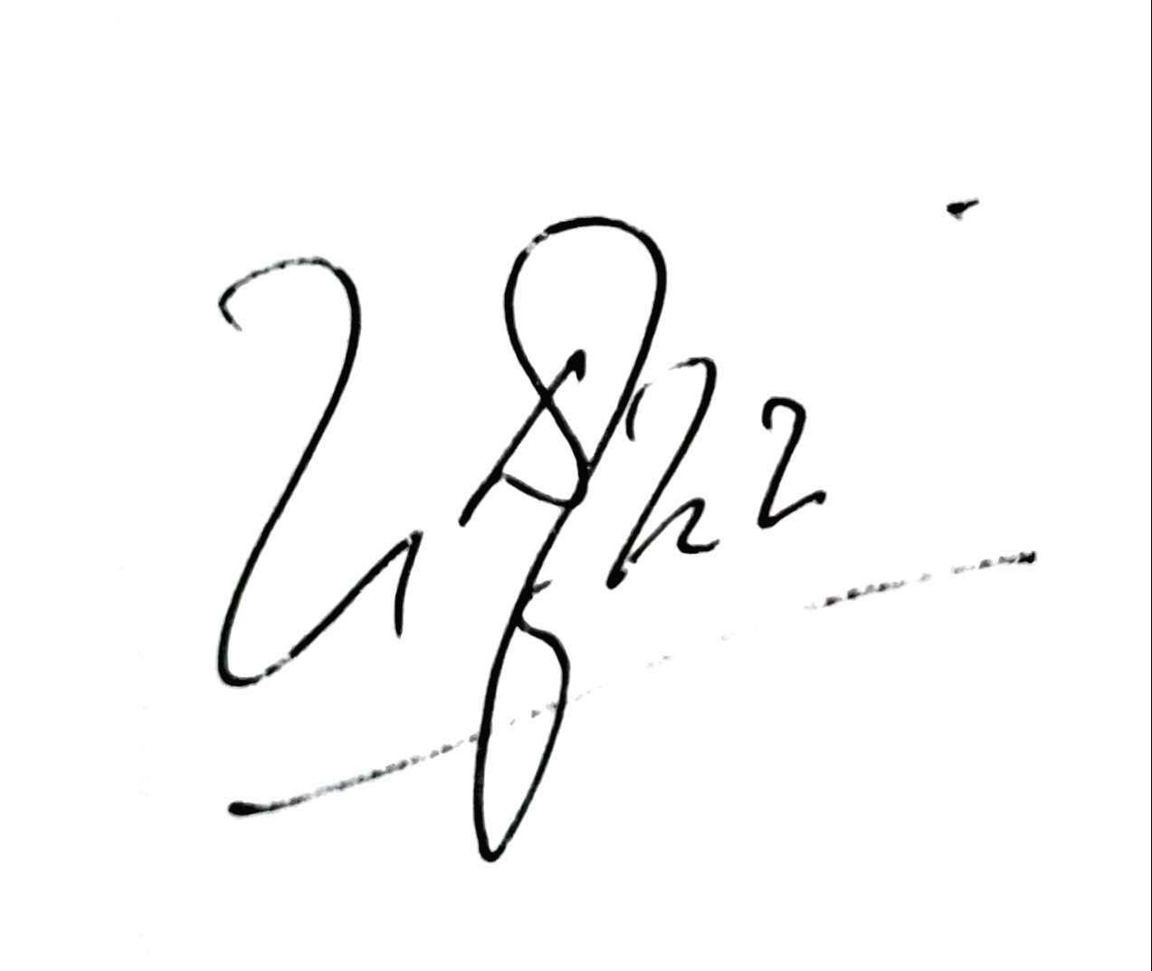 |  |  |  |  |  |  |  |  |  |  | Signature
 | Date: |  | 5 Mac 2025 |  |  |  |  |  |  |  |  |  |  | Date:

